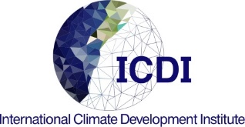
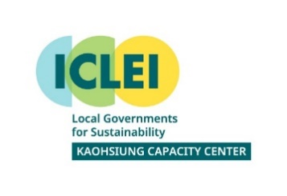
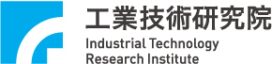
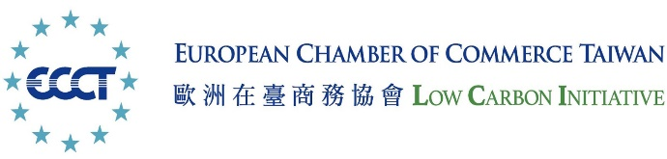

2022 Global Smart Solution Report
City Case Submission Form
Project/Solution Title: | _____________________________
City/Country/Company: | _____________________________
Department/Institution: | _____________________________
Date of Submission: | _____________________________

Please submit the completed form to:
RZ@icdi.asia

Section 1 – Project/Solution Summary
- Project/Solution contact details
City |  |  | Country
Contact Person,  Position |  |  | Department/  Institution
Telephone Number |  |  | Email address
Website
I certify that I am authorized to act and sign on behalf of __________________ (City Name).

By: Date:

- Brief Project/Solution Information
Category |  | 選擇一個項目。
Solution/Project title
Project Duration |  | 按一下這裡以輸入日期。to 按一下這裡以輸入日期。
Linking SDGs |  | Please fill in the SDGs which are relevant to the solution/project.
Case summary  (max 300 words) |  | Please provide a brief description of the proposed project/solution, including the objectives and primary measurable benefits
Note: Please adjust the table as required for your description

Section 2 – Detailed Project/Solution Description
- City Context
Please describe relevant city, political, economic, and/or cultural factors that help to contextualize the project/solution, including existing city policies and strategies.
- Urban Challenges, and Case Objectives
Please clearly describe the urban challenges or developing problems the city has encountered, and the outcomes and the impact that the project/solution aims to achieve in improving the challenges

- Project/Solution Description
Elaborate on the method, strategy, policy or tools of the “smart” solutions and how they achieve breakthroughs or establish model examples.

- Results
Provide information on how the activities are linked to objectives, outputs and outcomes that the project/Solution intends to achieve.

It is also welcome to elaborate on the additional benefits that it brings (e.g. reduction in cost, time spent, and labor, introduction of innovative measures, or creation of business or employment opportunities, etc.).
- Governance, Engagement and Partnership
Describe the roles of stakeholders; the engagement of any public-private partnership/ public participation/ cross-sector or multi-level cooperation in the program.
- Reflections/Plans for the Future
Explain any challenges or difficulties encountered in the process of application and how it was overcame.

Provide suggestions for peer cities or describe any future plans or concepts for related projects.

- Photos (10 max.) or Video (10 min max.)
Provide links to images/videos separately.

Note: Please adjust the table as required for your description

Section 3 – Authorization and Consent

Authorization and Consent
To
Use Photograph or Image

I, representing the city of (NAME OF CITY) hereby grant International Climate Development Institute (ICDI) and ICLEI Kaohsiung Capacity Center (ICLEI-KCC) permission to use the provided photographs or electronic images in the publication of 2022 Global Smart Solution Report, including hard copies and soft copies, without payment or any other consideration. I understand and agree that these materials will become the property of the organizations and will not be returned. I hereby irrevocably authorize ICDI and ICLEI-KCC to edit, alter, copy, exhibit, publish or distribute these images for purposes of publicizing the 2022 Global Smart Solution Report or for any related lawful purpose.

I have read this release before signing below and I fully understand the contents, meaning and impact of this release.
________________________________________
(Name)

________________________
(Position)
________________________________________
(Department)

I certify that I am authorized to act and sign on behalf of (City Name).
__________________________________
(Signature) (Date)

CONTACT INFORMATION
International Climate Development Institute (ICDI)
Rebeca Zhang
+886-2-2395-9570
e-mail: RZ@icdi.asia

