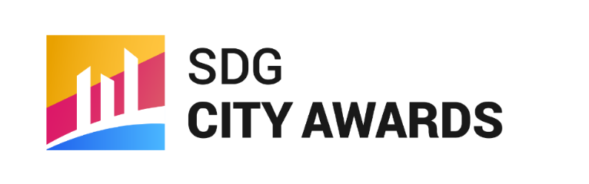
3rd SDG City Awards CASE STUDY Submission Template

Submit this form through the link on the SDG City Awards website

Urban SDG Knowledge Platform
The Urban SDG Knowledge Platform has been developed by the United Nations Economic and Social Commission for Asia and the Pacific (ESCAP), the Seoul Metropolitan Government (SMG) and CityNet to support cities in implementing the UN Sustainable Development Goals (SDGs). The Platform facilitates city-to-city knowledge sharing through provision of a repository of urban policies and initiatives that are working towards local implementation of SDGs. The urban policies and initiatives are sourced directly from local government representatives, which provides them with an opportunity to share information about urban policies and initiatives from their cities, as well as gain first-hand knowledge about emerging solutions and innovative practices from other cities. The uploaded policies and initiatives should be recent and directly related to the Sustainable Development Goals.

UN SDGs
The 2030 Agenda for Sustainable Development, adopted by all United Nations member countries in 2015, calls on countries to achieve 17 Sustainable Development Goals (SDGs) by 2030. Among the goals is the urban-dedicated Goal 11 which aims to ‘make cities and human settlements inclusive, safe, resilient and sustainable.’ Critically, it will not be possible to achieve all 17 SDGs without action from cities and local governments. Regional authorities and communities should take the initiative to adopt the SDGs at a local level and promote sustainable urban livelihoods.

CityNet-UN ESCAP SDG City Awards
The CITYNET-UN ESCAP SDG City Awards is the Urban SDG Knowledge Platform’s annual program to recognize the achievements of local governments in localizing the SDGs through innovative urban policies. You may use this template to prepare your case study before uploading it to the Platform through the submission page. Please refer to the SDG City Awards main webpage for more information regarding the awards program, thematic categories, partnering institutions, judge panel, evaluation criteria, and application deadline.
To submit the case study, please first log in to your account on the Urban SDG Knowledge Platform and upload your completed template file and any associated images or other media in the appropriate box on the submission page. You may create a free account through the JOIN page. After you have submitted the case study, pending approval and final edits, your policy/initiative will be featured in the Case Study Database on the Urban SDG Knowledge Platform. For any inquiries regarding the SDG City Awards or the submission process, please contact the site administrator by emailing sdgplatform@citynet-ap.org.

3rd SDG City Awards CASE STUDY Submission Template

First, please fill out the basic information below. Fields marked with an asterisk* are required.

Title of Case Study*

Name of Submitting City / Local Government / Organization*
Ex. Seoul Metropolitan Government / Gyeonggi Province / University of Seoul Intl. School of Urban Sciences

Name of Case Study Focal Point*
Who is submitting this case study on behalf of your city / organization? Please include a title (Mr. Ms. Etc.)

Focal Point Email Address*

Focal Point Phone Number

Awarding
If selected as a finalist, would a representative from your city or organization be willing to attend the SDG City Awards Ceremony on November 19th in Iloilo City, Philippines?

☐ Yes
☐ Yes, only with Sponsorship (local accommodation and/or flight tickets)
☐ No

3rd SDG City Awards CASE STUDY Submission Template

Category Selection
Please select the most appropriate thematic category for your case study submission. To be eligible for the SDG City Awards, each case study must align with at least 1 of the categories for a given year. You may select as many that apply. If you are not sure, select the last option and the Secretariat can find the best fit.
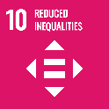
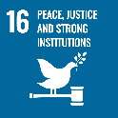
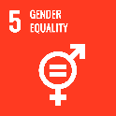
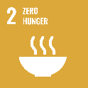
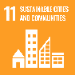
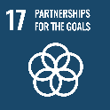
☐ Category 1: INCLUSIVE CITY
Linked SDGs: 11, 2, 5, 10, 16, 17
The INCLUSIVE CITY Category recognizes sound planning that makes cities safer and more accessible for all. It encapsulates the “Leave No One Behind” ethos of the SDGs.
Examples) Social welfare programs, Urban regeneration, Placemaking, etc.
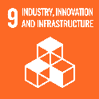
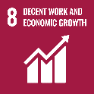
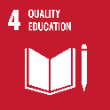
☐ Category 2: SMART CITY
Linked SDGs: 11, 4, 8, 9, 17
The SMART CITY Category covers policies related to data-driven cities, digital transformation, and ICT technologies for urban spaces. It incorporates infrastructure, transportation, industry, and education.
Examples) Data & Apps, Public transport policy, PPP, Work improvement programs, etc.
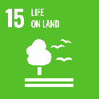
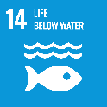
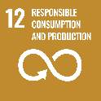
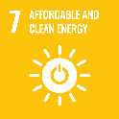
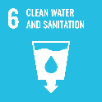
☐ Category 3: CIRCULAR CITY
Linked SDGs: 11, 6, 7, 12, 14, 15, 17
The CIRCULAR CITY Category is for policies related to energy and resource management for the promotion of a Zero Waste city. These policies contribute towards making the city more resource efficient.
Examples) Solid waste management, Water treatment, Waste to energy, Sustainable tourism, etc.
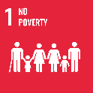
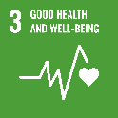
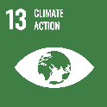
☐ Category 4: RESILIENT CITY
Linked SDGs: 11, 1, 3, 13, 17
The RESILIENT CITY Category recognizes cases that make cities more adapted to shocks in the form of threats from climate change, disaster, health, & poverty including practices that mitigate negative impacts.
Examples) Disaster-risk reduction, GHG emissions reduction, Pandemic response, etc.

☐ Not Sure
(if applicable, the Awards Secretariat will select the most appropriate category)
3rd SDG City Awards CASE STUDY Submission Template

※ Please complete the case study template. Fields marked with an asterisk(*) are required.
SECTION |  |  | INSTRUCTIONS
CASE STUDY OVERVIEW
Title * | Title of Initiative/Policy/Programme/Project
Synopsis * | Describe the initiative in one or two sentences (140 characters max)
City * | Name of city
Country * | Official country name
Region * | Select region and relevant subregion |  |  |  | Asia and the Pacific  Subregion:  ☐ Central Asia  ☐ Eastern Asia  ☐ Southeastern Asia  ☐ Southern Asia  ☐ Western Asia  ☐ Pacific  ☐ Northern Africa  ☐ Sub-Saharan Africa  ☐ Northern America  ☐ Latin America and the Caribbean  ☐ Western Europe  ☐ Eastern Europe  ☐ Oceania
Implementation Period * | Select the status of the initiative |  |  |  | ☐ Planned  ☐ Being Implemented  ☐ Complete  Start year:  Completion Year:
Stakeholders and Partners * | List the key organizations, stakeholders, and government departments involved in this initiative, including any collaborative or cross-departmental coordination mechanisms.
Themes * | Select the key theme(s) that this initiative is related to. If selecting 'Other', please describe. |  |  |  | ☐ Urban Planning  ☐ Housing  ☐ Transport  ☐ Water and Sanitation  ☐ Energy  ☐ Solid Waste  ☐ Environment and Resilience  ☐ Governance and Finance  ☐ Social Inclusiveness and Well-being  ☐ Economy and Jobs  ☐ Other – please describe:
Sustainable Development Goals * | Select the most relevant Sustainable Development Goal(s) and associated target(s) that this initiative is working towards.  Further information about the SDGs is available at:  http://www.un.org/sustainabledevelopment/sustainable-development-goals/ |  |  |  | ☐ Goal 1 - End poverty in all its forms everywhere  ☐ Goal 2 - End hunger, achieve food security and improved nutrition and promote sustainable agriculture  ☐ Goal 3 - Ensure healthy lives and promote well-being for all at all ages  ☐ Goal 4 - Ensure inclusive and equitable quality education and promote lifelong learning opportunities for all  ☐ Goal 5 - Achieve gender equality and empower all women and girls  ☐ Goal 6 - Ensure availability and sustainable management of water and sanitation for all  ☐ Goal 7 - Ensure access to affordable, reliable, sustainable and modern energy for all  ☐ Goal 8 - Promote sustained, inclusive and sustainable economic growth, full and productive employment and decent work for all  ☐ Goal 9 - Build resilient infrastructure, promote inclusive and sustainable industrialization and foster innovation  ☐ Goal 10 - Reduce inequality within and among countries  ☐ Goal 11 - Make cities and human settlements inclusive, safe, resilient and sustainable  ☐ Goal 12 - Ensure sustainable consumption and production patterns  ☐ Goal 13 - Take urgent action to combat climate change and its impacts  ☐ Goal 14 - Conserve and sustainably use the oceans, seas and marine resources for sustainable development  ☐ Goal 15 - Protect, restore and promote sustainable use of terrestrial ecosystems, sustainably manage forests, combat desertification, and halt and reverse land degradation and halt biodiversity loss  ☐ Goal 16 - Promote peaceful and inclusive societies for sustainable development, provide access to justice for all and build effective, accountable and inclusive institutions at all levels  ☐ Goal 17 - Strengthen the means of implementation and revitalize the global partnership for sustainable development
Briefly explain how this initiative contributes to the relevant SDGs and associated targets.*

Please use the questions below to guide your response:
• How does this initiative effectively address multiple SDGs and associated targets?
• Has this initiative been designed from the start to address specific SDGs and associated targets?
• How does this initiative contribute to your country’s national-level SDG strategies?

DETAILED INFORMATION
Key City Information |  | Local Government Website
 |  | City Social Networking Sites (Facebook, Twitter, etc.)
 |  | City Population
 |  | City Area (Km²)
Background, Challenges and Objectives * |  | Describe what challenges/gaps the initiative is addressing, including any relevant background information about the city, and outline the key objectives/goals of the initiative.  Please use the questions below to guide your response  • How have factors such as the city's history, population size, and location influenced the need for this initiative?  • What challenges and opportunities faced by the city influenced the development of this initiative?  • Why was this particular approach chosen?  • What are the key objectives/goals of this policy?
Actions and Implementation* |  | Describe the key actions taken under this initiative, including any relevant information about its implementation timeline.  Please use the questions below to guide your response  • What key actions and stages were involved?  • What community engagement or participatory planning processes have been involved?  • What monitoring and evaluation measures have been put in place?  • What is the strategy to keep this practice going over the mid- and long-term?
Outcomes and Impacts * |  | Provide a brief overview of the outcomes and impacts of the initiative.  Please use the questions below to guide your response  • What has been achieved and who is benefitting?  • How has success been measured?  • What factors and conditions contributed to its success and/or presented challenges?  • How does this initiative benefit disadvantaged and marginalized groups?
Replicability and Scalability * |  | Describe the suitability of this initiative to be replicated and scaled-up, including the factors and risks which parties interested in replication should consider during the planning of similar projects.  Please use the questions below to guide your response  • Can this practice or parts of it be replicated or was its success local context-specific?  • In what urban contexts would this initiative be best-suited for replication?  • What are the key takeaway lessons relevant to parties interested in replication? • What are the prospects for scaling up implementation to benefit a larger number of people?
Budget and Resources Allocated |  | Describe the resources that have been allocated to the planning, implementation and ongoing maintenance of this initiative.  Please use the questions below to guide your response  • What is the budget (USD) of the initiative?  • Has the policy received any external resources or support, such as external financial contributions?  • What internal resources (for example, human resources/staff, technical expertise etc.) have been allocated?  • What other resources, such as data and technology, have been utilized?
Further Information and Media* |  | Do you have any images, documents, or videos to share along with the submission template form? Each case study requires at least 1 main image to represent the policy and act as its thumbnail image on the platform. Please share supplementary images and other media by:  A). Attaching the images to the submission box on the SDG City Awards website and submitting them together with this template.  B). Pasting links to shared cloud storage folders below.  C). Pasting images directly into this word document.  Cloud storage links to associated media (Google Drive, Microsoft OneDrive, Dropbox etc.)  Paste links here:  - As images speak a thousand words, we would prefer the images to be of high quality. Please consider sending high quality images via Google Drive or similar applications.  - By sharing the images, documents, video links etc. you agree that these media can be utilized within the Urban SDG Knowledge Platform website and related publications. You also acknowledge that you possess the copyright to distribute the images to an external party.
Contact Details |  | This information will be made public on the Platform. If you do not wish your email address and/or phone number to be displayed publicly, please indicate ‘available upon request’.
 |  | Name*
 |  | Position/Role *
 |  | Organization *
 |  | Email
 |  | Phone

