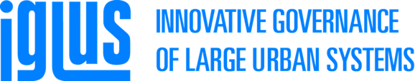
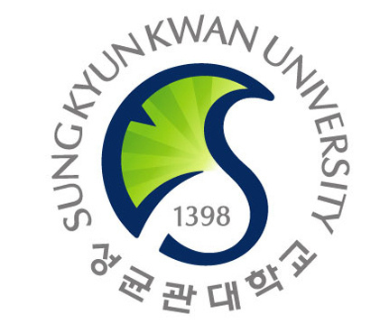
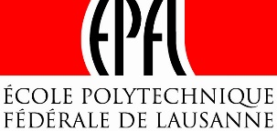

Training program in Innovative Governance of Large Urban systems

Dear Colleagues,

We are pleased to inform you that the next training module of the EPFL’s Executive Master in the Innovative Governance of Large Urban Systems (IGLUS) is going to take place in Seoul, South Korea, from 6th to 17th of June 2016, jointly organized with Sungkyunkwan University, and in collaboration with The World Bank, UN-Habitat and the University of Seoul.
It aims at making city managers of tomorrow understanding how to go towards smarter and more efficient urban systems, by focusing on the management and governance of transportation, energy and water infrastructures.
We currently have some scholarships available for highly qualified candidates in a management capacity (e.g., city managers), who have at least a 4 years bachelor degree, preferably a master’s degree, as well as at least 5 years of professional experience. If you are interested, send an email to iglus@epfl.ch
The IGLUS Executive master is accredited and offered by EPFL (which consistently ranks among the world’s top 15 universities) and structured on a rolling basis around 6 two-week training modules taking place in six locations around the globe; namely in Mexico-Guadalajara, the United Arab Emirates, Istanbul, Seoul, Detroit-NYC, and Dortmund.
.

